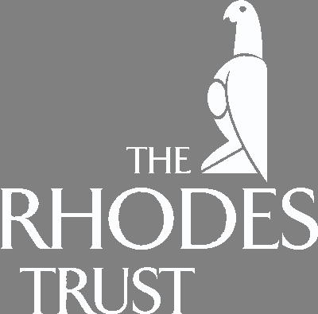

Sir Colin Lucas, Warden of Rhodes House,

cordially invites you to attend
a breakfast for Rhodes Scholars
at the Oxford North American Reunion
Waldorf=Astoria Hotel
Norse Suite, 18th Floor

301 Park Avenue

New York, New York 10022
on Saturday April 5, 2008 from 7:15 - 8:15 am

RSVP by March 22, 2008
Helena.Snow@rhodeshouse.ox.ac.uk

